Experiment No. 1
A Comparative Study of Traditional Software Development and Low-Code Development Approaches
1. Aim
To analyze and compare the Traditional Application Development approach with the Low-Code Development approach with respect to coding effort, development speed, flexibility, cost, and deployment efficiency.
2. Introduction to Traditional Application Development
Traditional application development refers to the conventional practice of building software applications by writing the entire source code manually, using programming languages such as Java, Python, C++, C#, or JavaScript. Developers following this approach must have a strong understanding of programming logic, system architecture, database design, and testing procedures.
This method generally follows the Software Development Life Cycle (SDLC), which includes phases such as planning, requirement analysis, design, implementation, testing, deployment, and maintenance. Because developers retain full control over the source code, traditional development is well suited to large, complex, and highly customized enterprise systems. The trade-off is that it demands experienced engineers, longer development timeframes, and greater financial investment.
Advantages
- High degree of customization
- Strong performance for large-scale systems
- Well suited for complex enterprise applications
- Complete control over the source code
Disadvantages
- Lengthy development cycles
- Requires experienced programmers
- Higher cost of development and maintenance
- Extended testing and release cycles
3. Introduction to Low-Code Development
Low-code development is an approach that allows applications to be assembled mainly through visual tools, including drag-and-drop interfaces, prebuilt modules, and visual process designers, with only a small amount of manual coding. It shortens development timelines by reducing repetitive programming tasks.
Low-code platforms typically provide ready-made templates, reusable components, workflow automation, and built-in database connectivity, enabling both professional developers and citizen developers to build functional applications rapidly. Widely used low-code platforms include Microsoft Power Apps, OutSystems, Mendix, Appian, and Zoho Creator.
This approach is commonly applied to internal enterprise tools, business process automation, customer relationship management (CRM) systems, and rapid prototyping.
Advantages
- Quicker development turnaround
- Reduced amount of manual coding
- Lower overall development cost
- Simple to maintain and update
- Faster deployment
Disadvantages
- Restricted customization options
- Dependence on the chosen platform
- Ongoing licensing expenses
- Less suited to highly complex use cases
4. Diagram
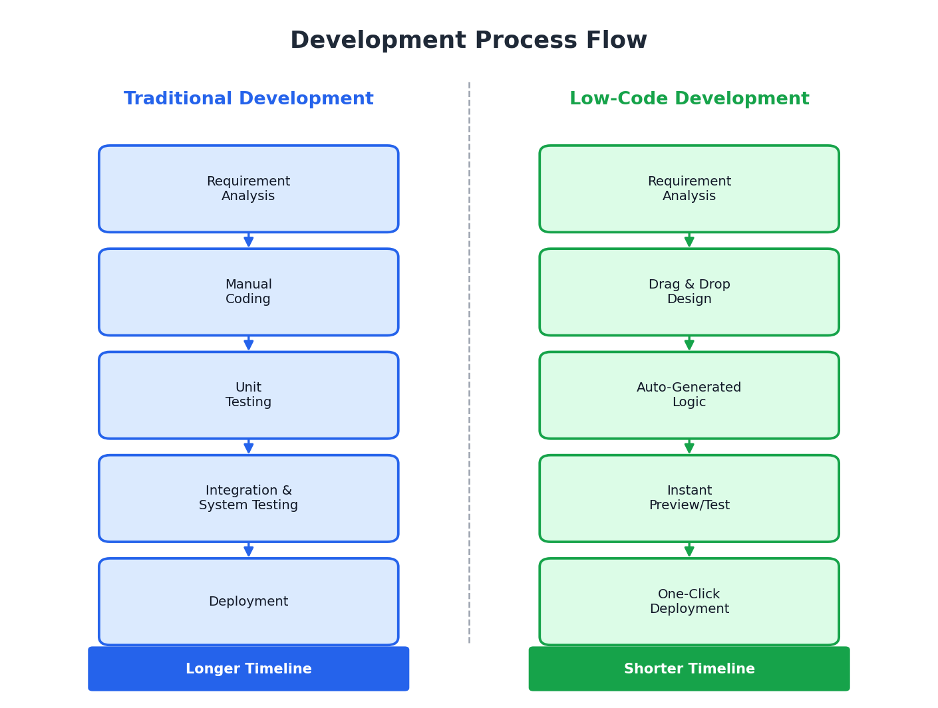
5. Comparative Analysis
Parameter | Traditional Development | Low-Code Development
Coding Effort | High | Low
Development Speed | Slow | Fast
Cost | High | Lower
Customization | High | Moderate
Development Time | Longer | Shorter
Maintenance | Complex | Easier
Technical Skill Needed | Advanced | Basic to Moderate

6. Result
The comparative study shows that Traditional Application Development offers greater flexibility, customization, and control, making it suitable for large and complex software systems, though it requires considerable coding expertise, longer development time, and higher costs.
Low-Code Development, on the other hand, enables faster application development with minimal coding effort, reduced costs, and quicker deployment. It is well suited for rapid application development, business process automation, and organizations aiming for a faster time-to-market. Hence, the choice between the two approaches depends on the project's complexity, customization needs, budget, and development timeline.

